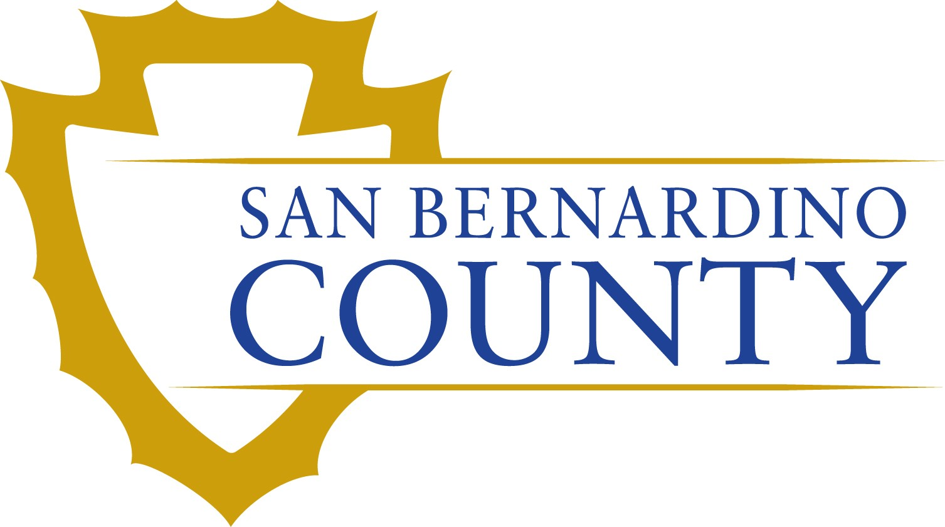
Monday
October 7, 2024

NOTICE IS HEREBY GIVEN, that San Bernardino County intends to release a Solicitation of Proposal (SOP) for Ramp Space C-100 at Chino Airport. unimproved land, consisting of approximately 1.5 acres, commonly known as C-100 for the development of aircraft parking ramp at a monthly rate of $3,267.00 and on other terms set forth in the SOP.

On Monday, October 7, 2024, an SOP Packet will be available to all interested parties. The packet may be picked up at the Airport Administration office in Building A-550. For additional information, you may contact Audrey Roque, Real Estate Services, 385 N. Arrowhead Ave., 3rd Floor, San Bernardino, CA 92415-0180, Audrey.Roque@res.sbcounty.gov

